**How to Run Docker Inside Jenkins**

1. First you need to create an AWS EC2 instance and install Jenkins and docker on it. And give the following commands: - **usermod -a -G docker Jenkins & systemctl restart jenkins**

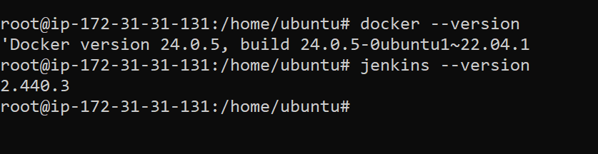

1. **Login to Jenkins using public ip and port 8080 on your browser**

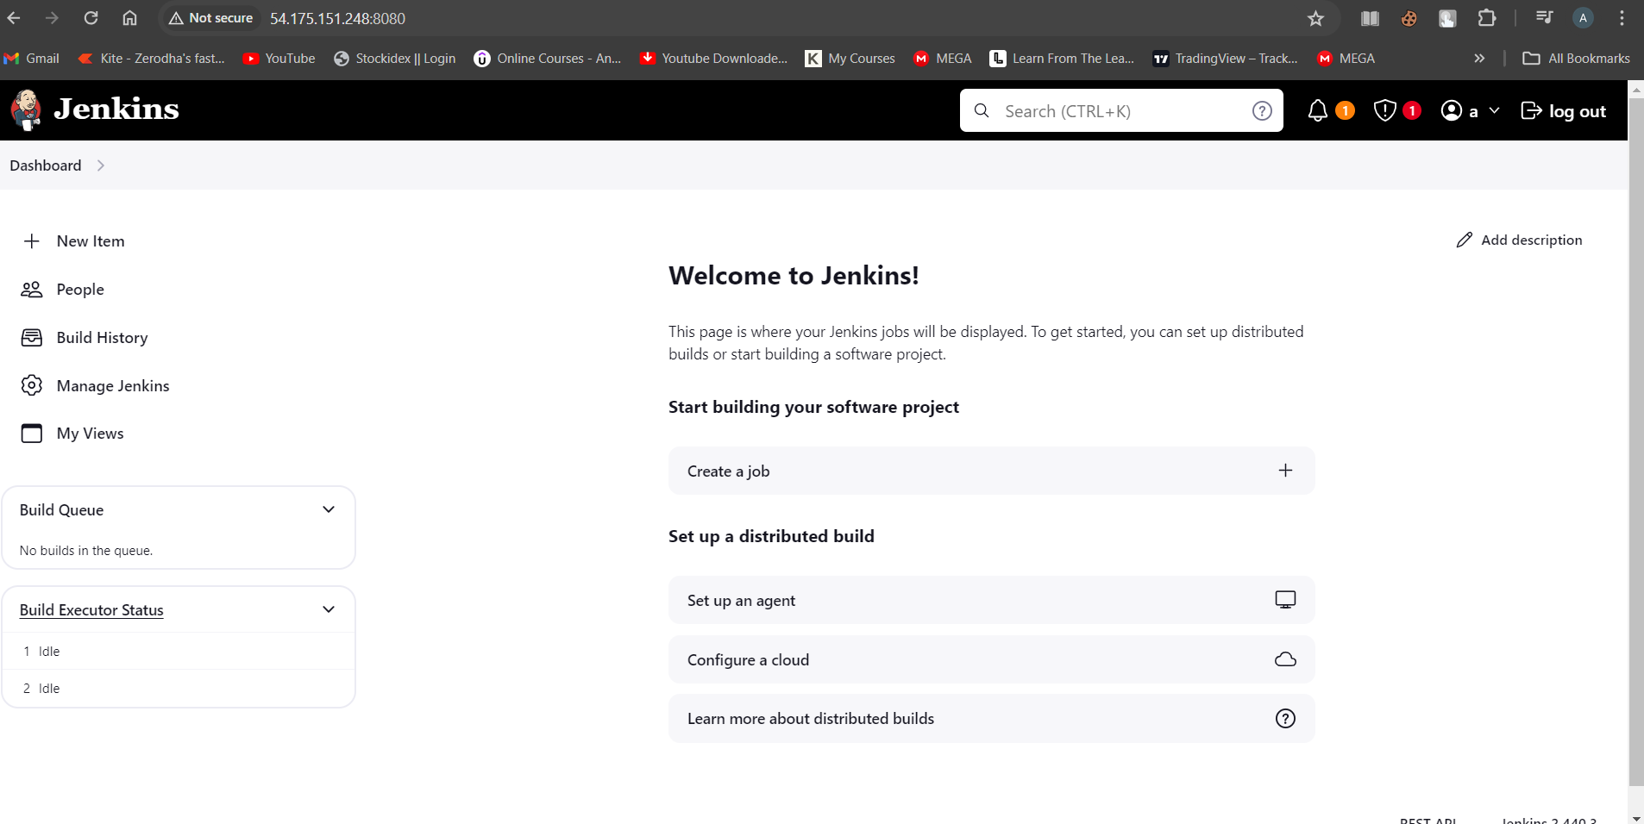

1. **Go to this path 🡪 Manage Jenkins🡪Plugins🡪Available Plugins**

**Search for docker and install below plugins**

**1.docker**

**2.docker-commons**

**3.docker-pipeline**

**4.docker-build-step**

**4. Go to Dashboard🡪New Item**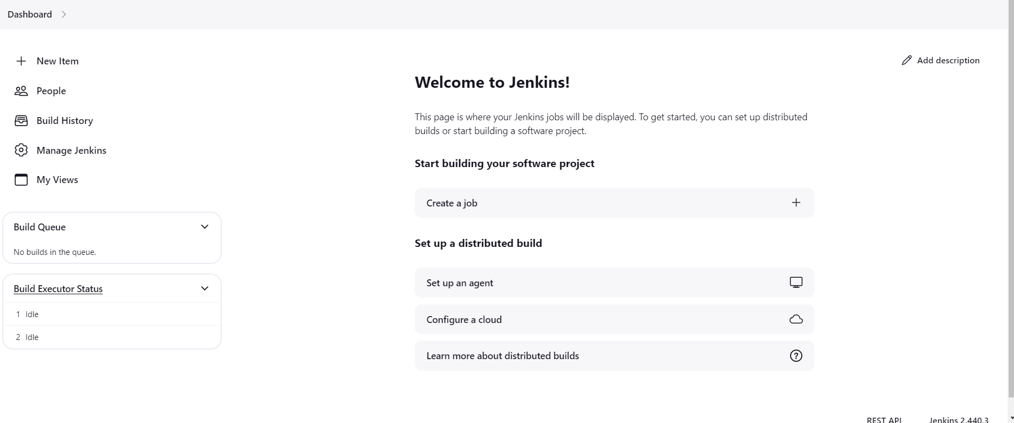

**5.Give name and select Pipeline project**

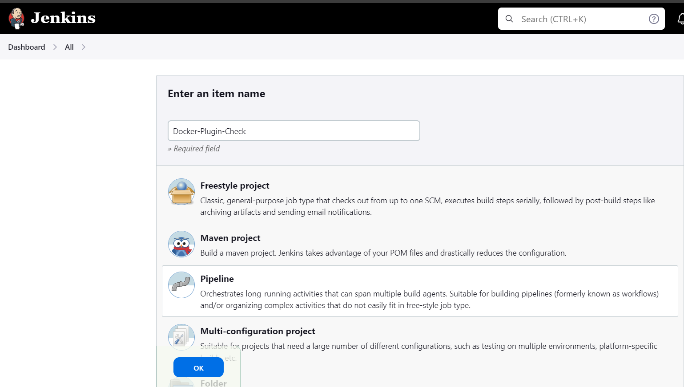

**5.Go to Pipeline section and select hello-world script**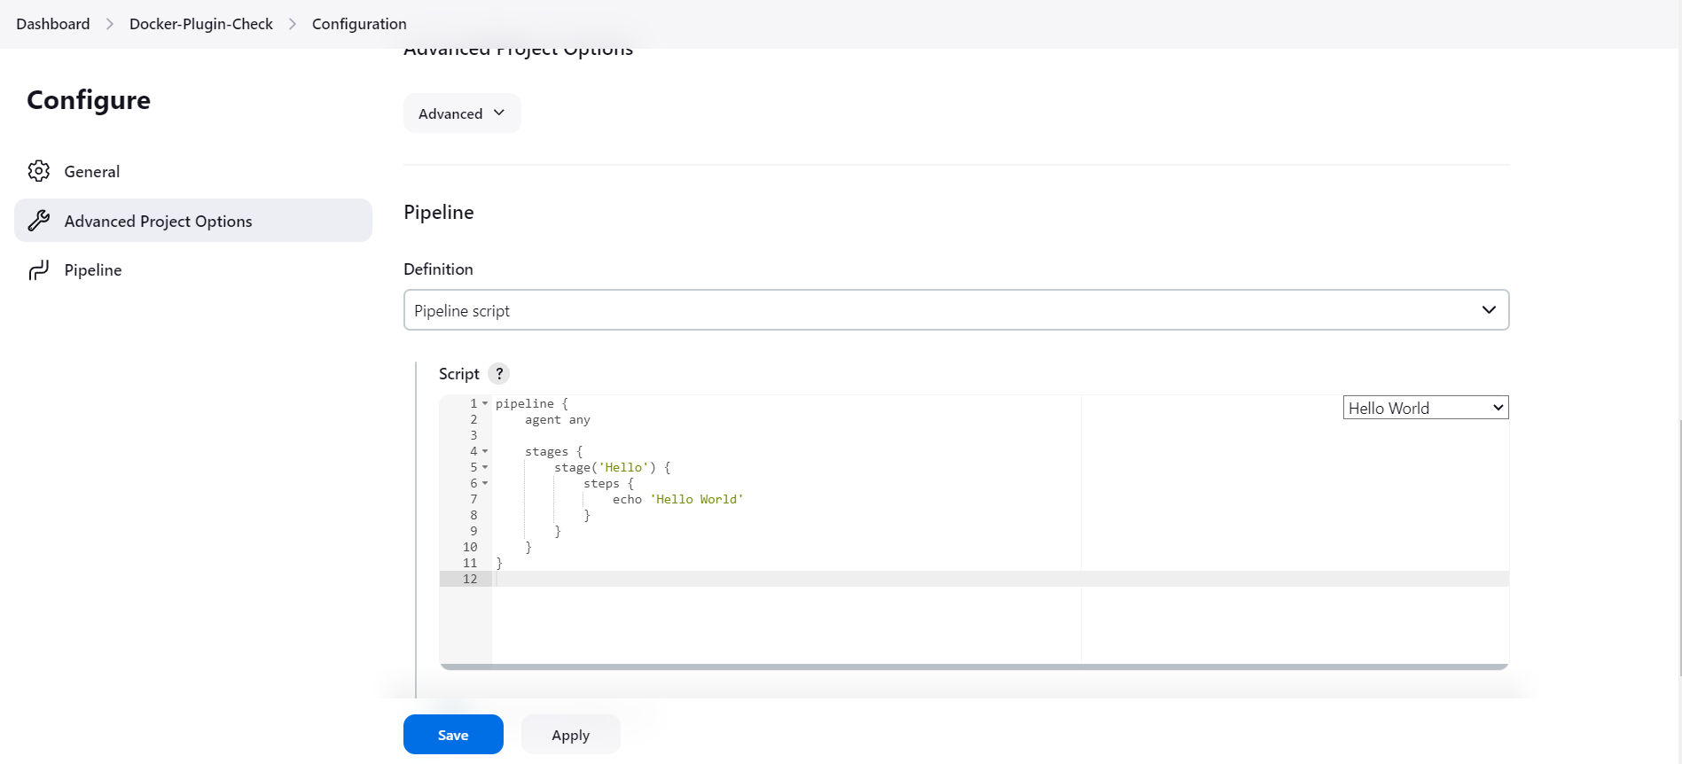

6.Write the following script & click apply-save

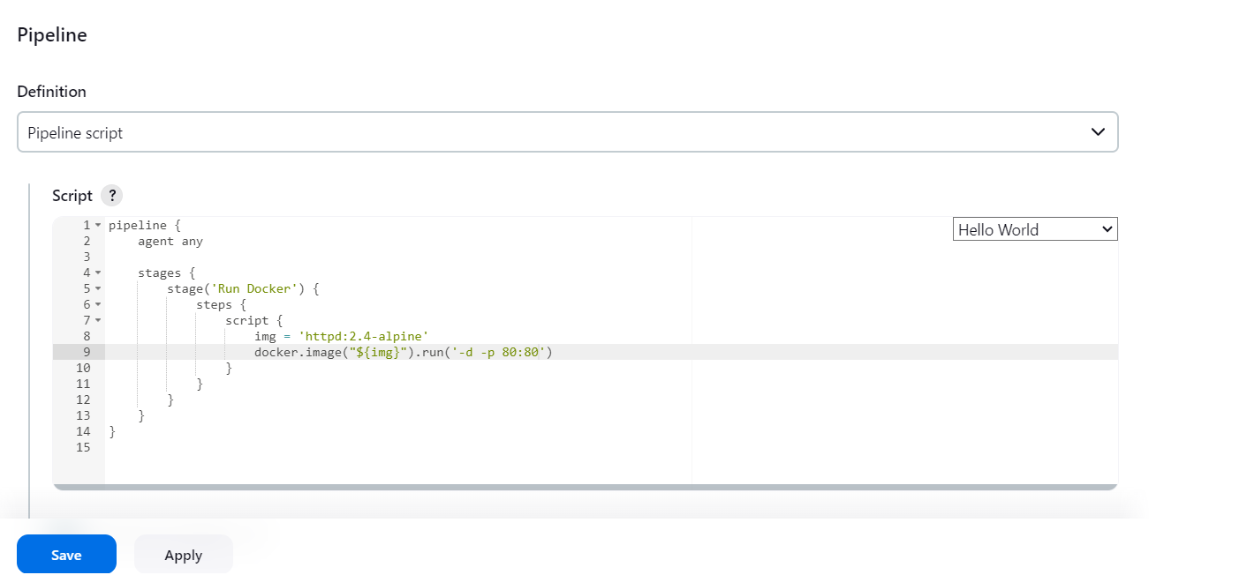

**7. Now click on Build Now and after build success go to console output** 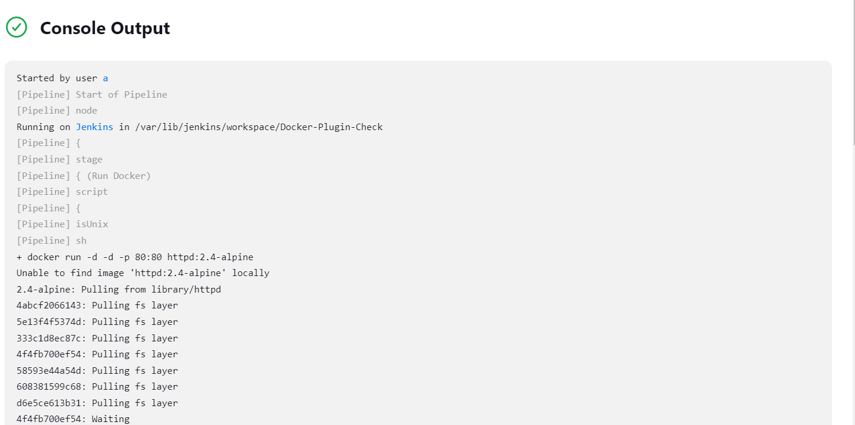

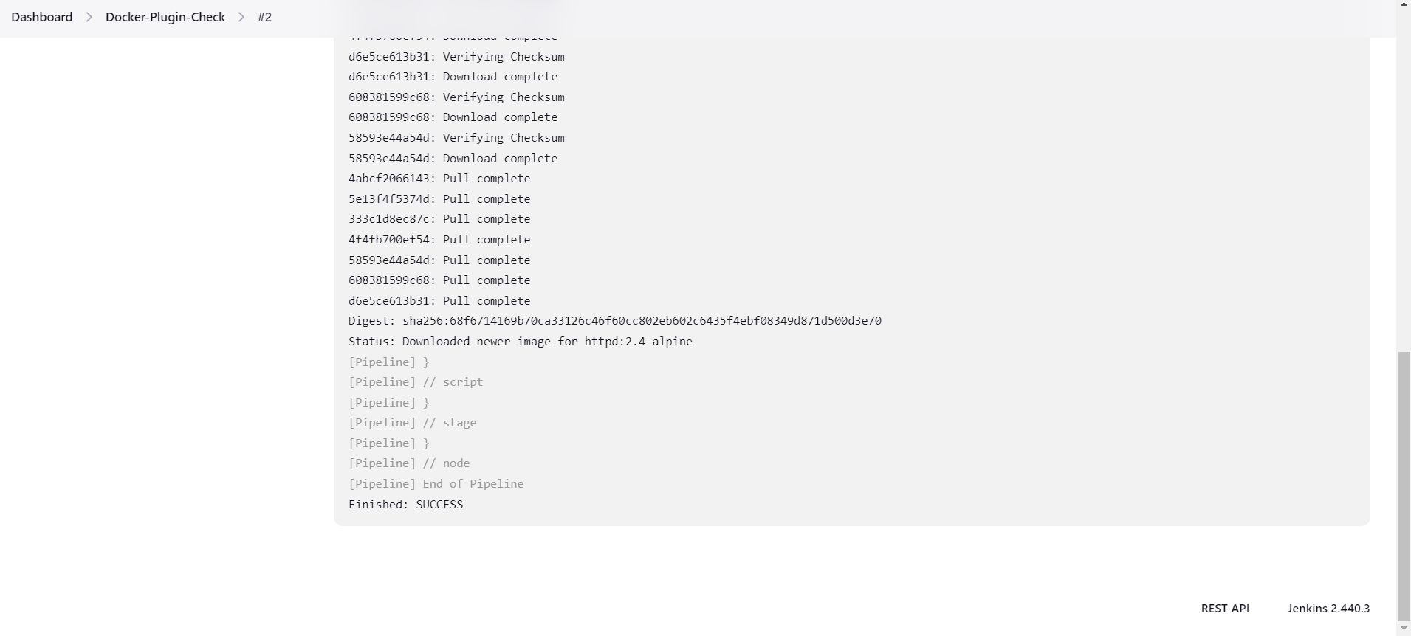

**8. Go to your terminal and give command docker images**

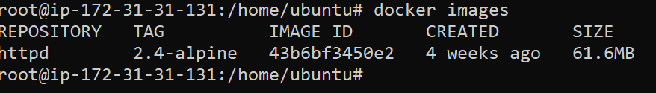

**9.Now give command docker ps -a to check whether a container has been created and running**



**10.Now copy public ip of your ec2 instance and give port as 80 and run it on your browser**



**Great!!!! You have successfully pulled a docker image and created a docker container and tested it on browser using jenkins**